**Design Document**

1. Development tools and environment
   1. Development tools : Android Studio
   2. Environment:

AndroidVersion.api: 28 Android9.0

1. Overall Architecture
   1. MainACtivity

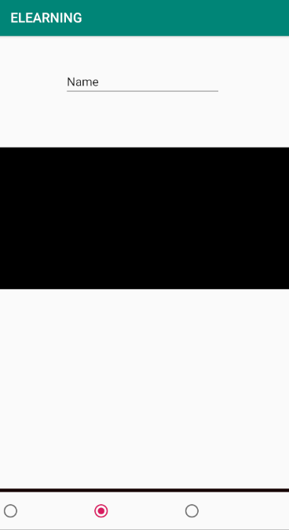

**Radio_Group**: Control the conversion of ly_contnet through this component

**Ly_content:** We can switch between list, browse, user center three fragments

* 1. List_fragment

**List_fragment**:   
Jump to content_fragment when clicked listitem

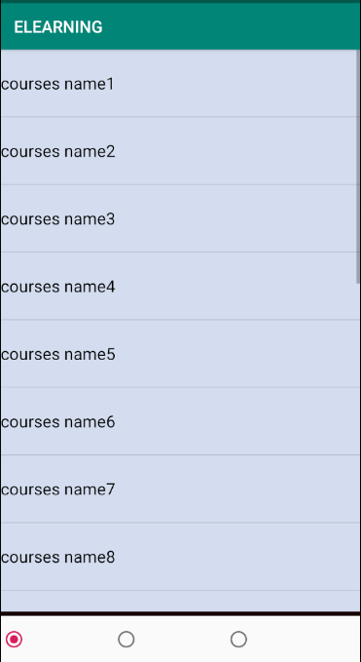

* 1. Browse_fragment



With this videoview we can browse multi media.

With this textedit we can serch

* 1. Login_Activity

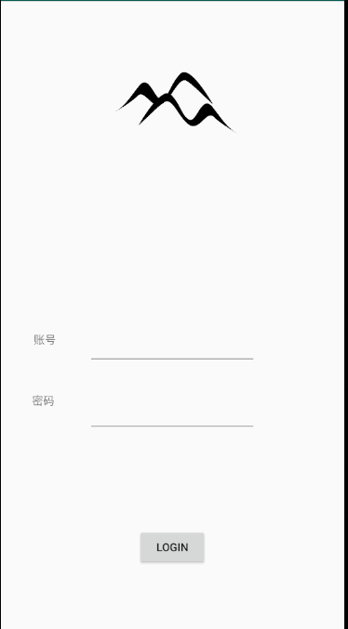

Click the login button will turn to mainactivity

1. Module Design

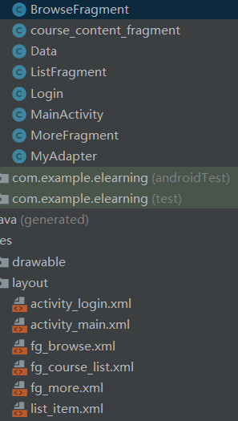

* 1. BrowseFragment

Through this fragment we can search the search the learing materials and display in the videoview.

* 1. Course_content_fragment

This fragment will display the detailed course introductions such as course info , syllabus, registration and calendar and so on.

* 1. Data

This class discribe the course data.

* 1. ListFragment

Course name list,and achieve the item click event

* 1. Login

Login interface

* 1. MainActivity

With radio group to control the fragment switch.

* 1. MoreFragment

More function.

* 1. MyAdapter

Let course list adapt the fragment.